MySQL PROJECT

1.Write a SQL query to count the number of characters except for the spaces for each actor.

Return the first 10 actors' name lengths along with their names.

[QUERY:]

**select * from actor;**

**select concat(first_name, last_name) from actor as NAME;**

**select length(first_name) + length(last_name) as NAME_LENGTH from actor; -- well, that's new '+'**

**select actor_id as COUNT,**

**concat (first_name, ' ', last_name) as NAME,**

**length(first_name) + length(last_name) as NAME_LENGTH from actor**

**limit 10;**

[OUTPUT:]

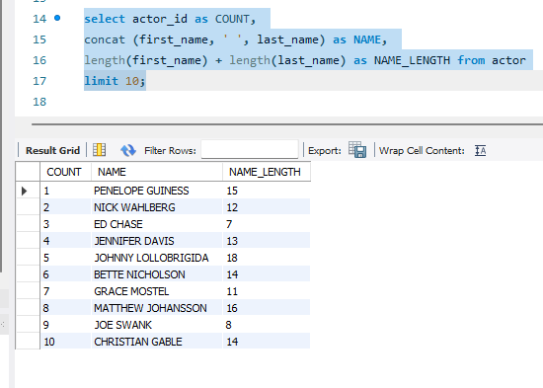

2.List all Oscar awardees(Actors who received the Oscar award)

with their full names and the length of their names.

[QUERY:]

**select * from actor; #actor_id**

**select * from actor_award; #actor_id**

**select concat(first_name, ' ', last_name) as OSCAR_AWARDEES,**

**length(first_name) + length(last_name) as NAME_LENGTH,**

**awards as AWARDS from actor_award**

**where awards like '%Oscar%';**

[OUTPUT:]

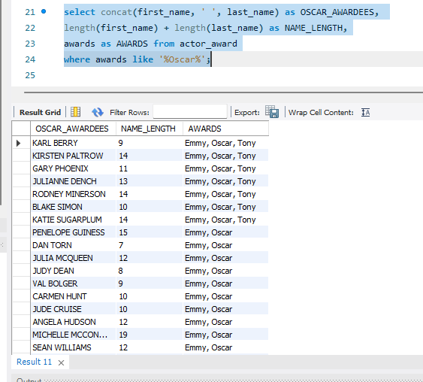

3.Find the actors who have acted in the film ‘Frost Head.’

[QUERY:]

**select * from actor; #actor_id**

**select * from film_actor; #actor_id, #film_id**

**select * from film; #film_id**

**select a.actor_id, concat(first_name, ' ', last_name) as NAME,**

**title as FILM_TITLE from actor as a**

**inner join film_actor as fa on a.actor_id = fa.actor_id**

**inner join film as f on fa.film_id = f.film_id**

**where title = 'Frost Head';**

[OUTPUT:]

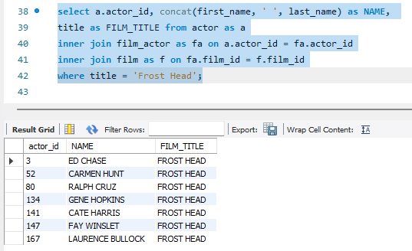

4.Pull all the films acted by the actor ‘Will Wilson’.

[QUERY:]

**select concat(first_name, ' ', last_name) as ACTOR, title as FILMS from actor as a**

**inner join film_actor as fa on a.actor_id = fa.actor_id**

**inner join film as f on fa.film_id = f.film_id**

**where a.first_name = 'Will' and a.last_name = 'Wilson';**

[OUTPUT:]

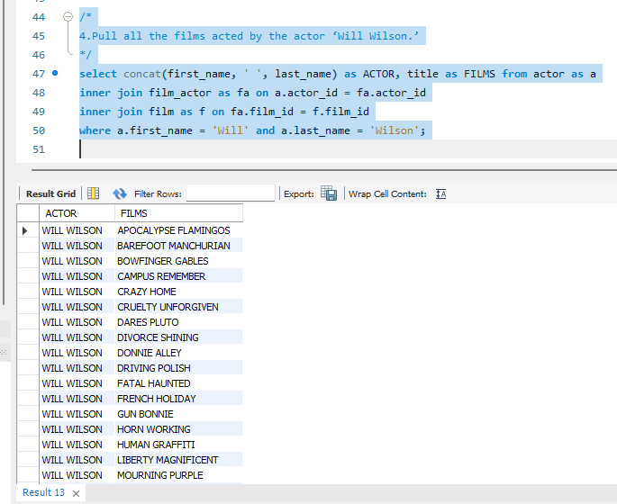

5.Pull all the films which were rented and return them in the month of May.

[QUERY:]

**select * from film; #film_id**

**select * from inventory; #film_id, inventory_id**

**select * from rental; #rental_id, inventory_id, customer_id**

**select title as TITLE, r.rental_date as RENTAL_DATE, r.return_date as RETURN_DATE from film as f**

**inner join inventory as i on f.film_id = i.film_id**

**inner join rental as r on i.inventory_id = r.inventory_id**

**where r.rental_date between '2005-05-01' and '2005-05-31'**

**and r.return_date between '2005-05-01' and '2005-05-31';**

[OUTPUT:]

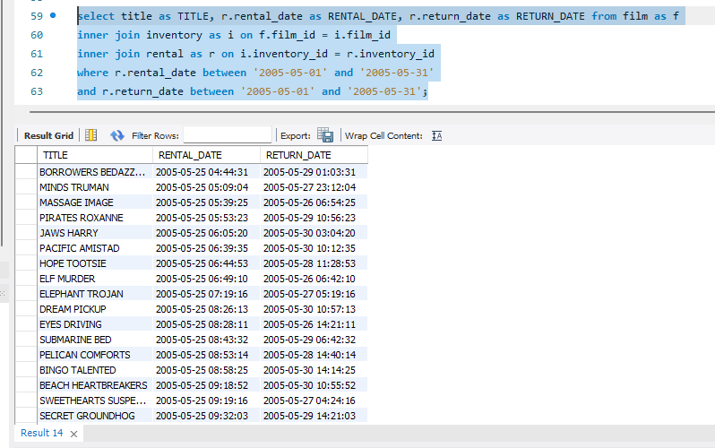

6.Pull all the films with ‘Comedy’ category.

[QUERY:]

**select * from film; #film_id**

**select * from film_category; #film_id, category_id**

**select * from category; #category_id**

**select f.title as TITLE, c.name as CATEGORY from film as f**

**inner join film_category as fc on f.film_id = fc.film_id**

**inner join category as c on fc.category_id = fc.category_id**

**where c.name = 'comedy';**

[OUTPUT:]



